# 

BRS FOR VITAL GUARD POP APP

(Mobile App)

Version: 1.3

Date:

**Table of Contents**

1. Project Goal 2

2. Features (Scope of Work) 3

3. App Credential: 12

# Project Goal

The goal of this application is to act as an emergency response in case of medical emergencies occurs to a user like sudden cardiac arrest. Thus through the use of blue tooth enabled Heart monitoring smart watches whereby if the value goes below the threshold value it will send automatic heart alert status to the emergency contacts as added by user if s/he is a free user type in the application. If the user is a subscribed user then it will enable 911 call option so that they can call to emergency service provider.

# Features (Scope of Work)

App flow and design Screens

1. User Screens:
2. **Splash screen:** once user downloads the app and open the app; they will be able to view the splash screen of the app *screen missing*
3. **Sign Up:** user can sign up in the application using their full name, email, password and password or they can use social login. The app will connect to social media for advertising and promotions.  
   *screen missing*
4. **Login:** user can login into their account using their email and password or with the help of social media accounts.   
   *screen missing*
5. **Forgot Password**: If user forgot their password, they will be able to click over the forget password and enter their registered email. A password reset link will be shared over that registered email id.  
   *screen missing*
6. **Home Screen (Family Tab):** screen displays the home screen of the application.
   1. **Profile icon**: it will navigate user to the profile screen of the user.
   2. **+ Icon**: It allow user to add the emergency contacts.
   3. **Track location**: it allow emergency contacts to view the user’s location if they have shared it with the emergency contacts. Please note that user has to keep their location access enable in the app so that in case of emergency bandwidth api will be able to share the location to the emergency service provider.

**NOTE: App once killed will not be able to access location.**

* 1. **Emergency contacts**: it displays the added emergency contacts.

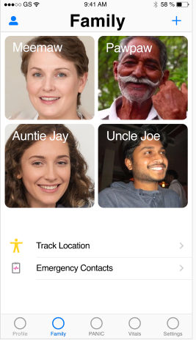

1. **Contacts:** allow user to open the contacts and add the other user to emergency contacts. Kindly note that user has to be available in the application so as to get added to the emergency contacts.

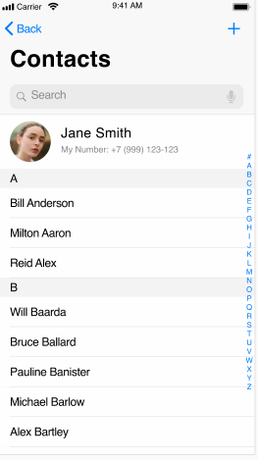

1. **Add Member:** Allow user to add as a family member in the application.

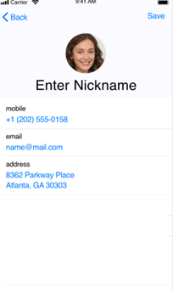

1. **Emergency Contacts:** The screen displays the list of emergencies contact added by user in the application.

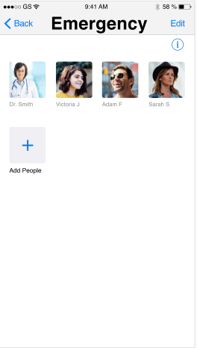

1. **Emergency Contacts 1:** The screen displays the emergency contacts where the user can add up to 4 contacts to whom the notification will be sent in case of emergency. This will be for the free user type. In case the user is a subscribed user then they can add more than 4 users under emergency contacts. (Maximum 10 emergency contact)

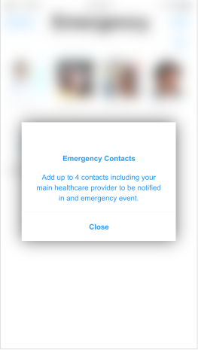

1. **Vitals:** the screen displays the information as received and recorded from the health kit api of the smart watch. Please note that if in case we do not receive any information of BPM, Temperature, Pluse Rate, Respiration rate, Blood oxygen level (Apple Watch Series 6 only) Systolic Blood Press from the watch sdk and if it doesnot support then we will be unable to present this inforamtion in the application. Also please note that information may differ based on the application platform (iOS/Android). This will be informed once we are in the development phase and review the sdk’s.

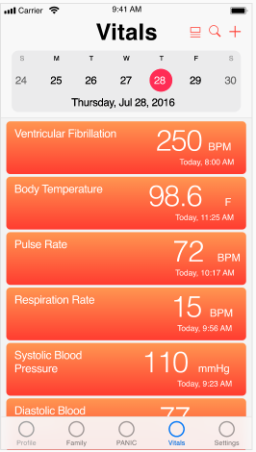

1. **History:** the screen displays the vital history recorded in the application. History recorded should allow user to take a print.

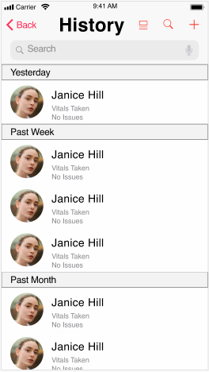

1. **Track Location:** The screen allow user to track the location of the other user of the application. For ex: User can track their mom or brother in the application if they have shared their location.

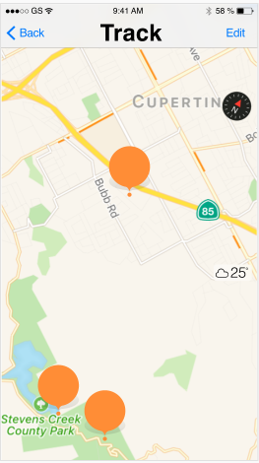

1. **Monitor:** Since we are unable to receive continuous signals thus it will be not be viable to get a signal (graph) like this. Here we will try if we can create a graph based on history and if not then it will be removed.

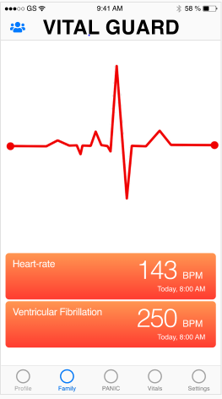

1. **Pop Over:** The screen shows the pop over box popped to upgrade the vital guard and to unlock the emergency life rescue. This notification can used to upgrade or can be closed by the user.

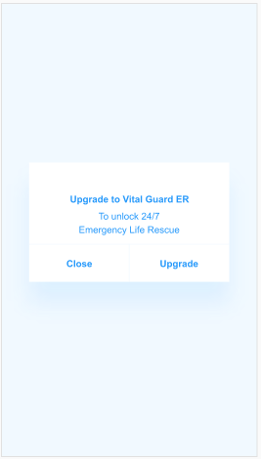

1. **User Profile:** The screen displays the profile of the user with the information like name, mobile, email and the address. Also user will be able to add a smart watch to the app so as to get the vital information as provided by the smart watch api into the application.

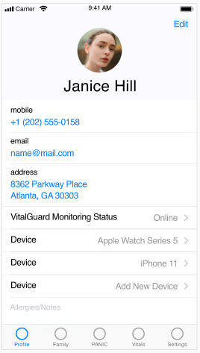

1. **Device:** allow user to disarm the application so then it stops any notification.

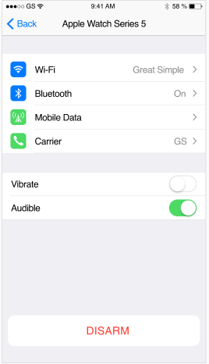

1. **Disarm:** Screen allow user to disarm the app as per the time defined by the user in the application.

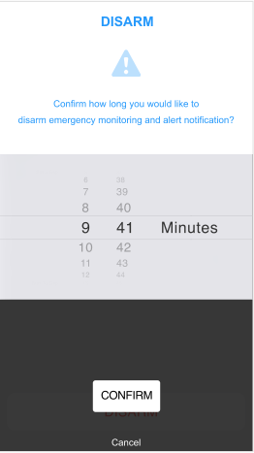

1. **Disarm 1:** screen displays the notification that the app is disarmed.

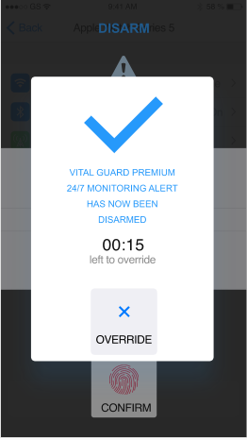

1. **Disarm 2:** screen allow the user to disarm the application, Password input is required to disarm the app.

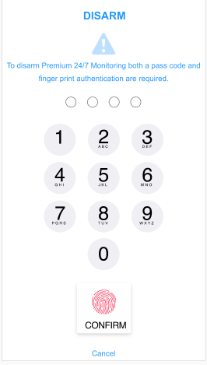

1. **Push Notifications:** these are the notification that the app send in case of emergency. In the event of heart failure emergency including v-fib in which the client /user may be incapacitated and unable to communicate to the 911 operator, premium user. Recommendation of an automated annunciation message indicating cardiac emergency be transmitted to emergency services/911, (Track location)

**screen missing**

1. **Subscriptions:** 
   1. Non Premium user:
      1. Non premium service will allow the user to send automatic heart alert status direct text message to the emergency contact added by the user.
      2. Non premium user will have an ability to select and input Emergency contact as 911 operator.
   2. Premium user
      1. Option to call 911 will be a premium feature.

***Note****: For this we will require 911 calling api to integrate and client has to share the same so that we can do the needful integration.*

* + 1. Option for user to add more than 4 emergency contacts in the application.
    2. The disarm option for the user to select a time duration for override must be limited to know more than 2 minutes.

**screen missing**

1. Admin web-panel:  
   Admin will be able to login over the platform by provided email and password.
2. **Users Management:**
   1. Admin will be able to view the registered user in the application.
   2. Admin will be able to enable / disable any user’s accounts in the application.
3. **Subscription Management:**
   1. Admin will be able to update the subscription price from the store for the premium user.

# App Credential:

Client to share below credentials while approving the document.

|  |  |  |  |
| --- | --- | --- | --- |
| S. No. | Description | Username | Password |
| 1 | Server hosting details |  |  |
| 2 | Apple store account login details |  |  |
| 3 | Duns Number with Company Account |  |  |
| 4 | Google Play Store credentials |  |  |
| 5 | Facebook for social login |  |  |
| 6 | Google for social login |  |  |
| 7 | Send grid details |  |  |
| 8 | Domain details |  |  |
| 9 | 911 api integration: https://www.bandwidth.com/911/emergency-calling-api/ |  |  |
| 10 | Twilio SMS api integrtion |  |  |

Please feel free to contact us for any queries. We would be happy to discuss over the BRS in detail. Thank You!

**☺--- END OF DOCUMENT ---☺**